|  |
| --- |
| Circle Language Spec: System Objects |

## System Objects

This chapter tries to demonstrate the internal workings of the symbols and shapes of Circle.

Circle Language Spec's aim is to show the notation of Circle, but this chapter tries to look at the internal workings as if it were an actual program. In doing so, finer details of Circle might start to show. Specifically, the usage of the *'system interface'* might come to light.

This hypothetical implementation supposes, that systems may all be composed of *system objects*. System objects would be the *actual* objects that other systems would be based on.

One of the purposes of system objects might be to manage *relationships* between objects.

A system object may also manage the *system aspects* of a symbol, such as its *class*, whether it *executes* or if it might store a *value*. These aspects could be controlled through *system commands*.

*Assignment commands* may also be system commands. An assignment command might copy an aspect from one object to another.

The *System Objects* documentation would also show *connectors, connections* and other notational forms that might come with controlling system aspects.

### The System Objects

#### The Object

In object oriented programming, an *object* might be considered the most basic element of a computer program. An object might represent a thing, an idea or a place, a number or a collection of other things or possibly anything else. All those things might be called objects.

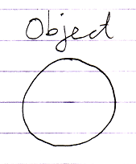

#### The Reference

We might usually be dealing with *references* to objects.

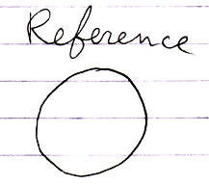

It might also be called a *pointer*.

An object might not be directly accessed. It could be used by other system objects to wrap an object reference into context.

#### Related Object

Another synonym for *object reference* might be *related object*. But a related object would be seen more from the point of view of another object.

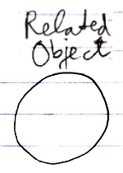

#### Item

Another name for an object might be an item. But perhaps an item is more about an object within a certain *context*.

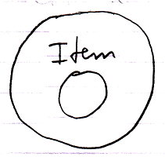

So an item would be like a related object.

#### Related Item

The term *related item* might be synonymous to the term *related object*. A parent object might contain *related items*.

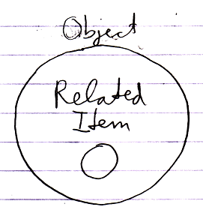

It would be the result of a relationship. A related item might wrap a reference to a related object.

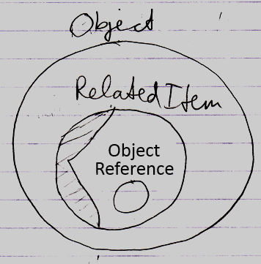

The reference is like a raw pointer, if you can imagine what that might mean, while a related item likes to decorate it with info like its class and perhaps procedures around it, like retrieving the object.

The term *related item* might be used to distinguish it from a *related list*.

#### Related List

A parent object might also contain *related lists*.

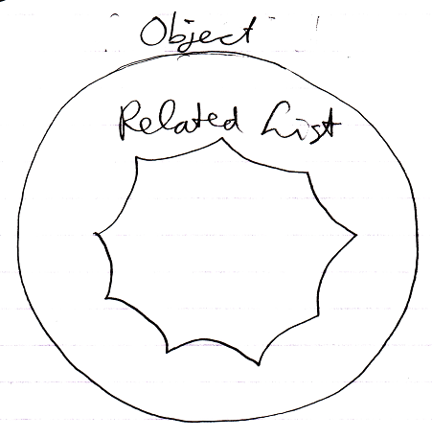

A related list might also be a related object, but perhaps a special one that might contain a scalable collection of other objects.

#### Related List Item

A related list may contain multiple *related list items*.

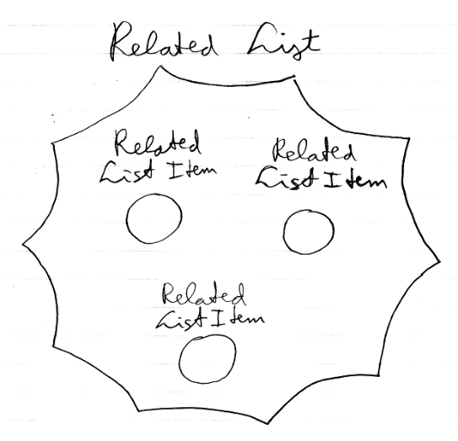

A related *list* itemmight be like a *related item*. What applies to related items might also apply to related *list* items. In some cases though, the behavior may be different.

#### Related Items & Related Lists Collections

An object’s related items and related lists might be stored as an object’s containing two collections: **Related Items** and **Related Lists**. The **Related Items** collection would contains all the related items of the object. The **Related Lists** collection would contain all the related lists of the object.

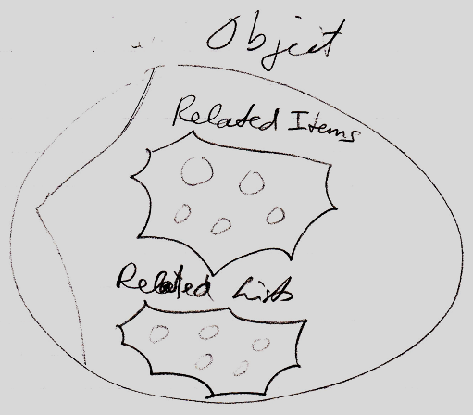

To see them in a diagram the picture above cracked open the 'system interface':

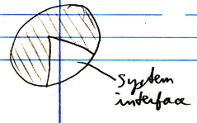

"and a little further"

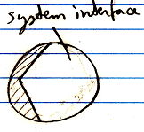

More may follow about the system interface notation later.

#### Reflective Data

It might just be an arbitrary choice to specifically have a *related items* collection and a *related lists* collection under the hood of a symbol. It favors the distinction between **1** related item and **n** related items.

There could be variations on that.

One variation might be: having a single related objects collection:

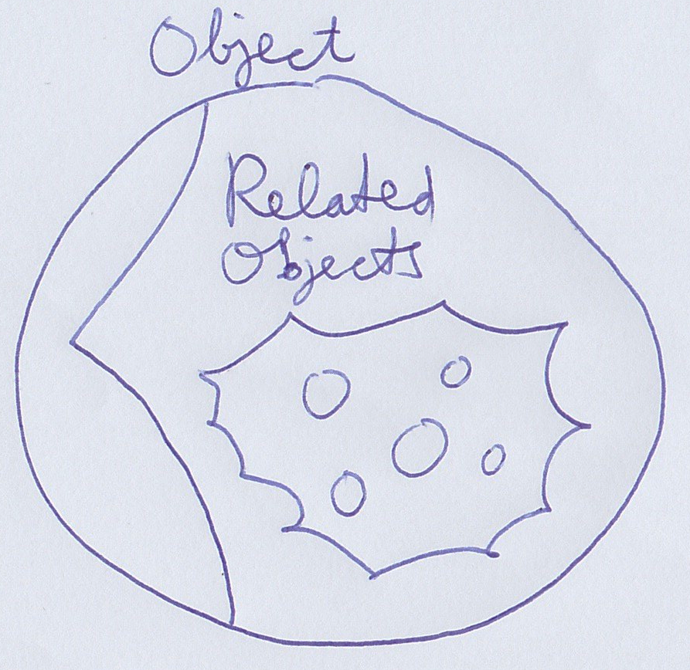

Lists might also be in the same collection. The single related objects collection might simply contain both lists and single items.

Another variation might add another collection:

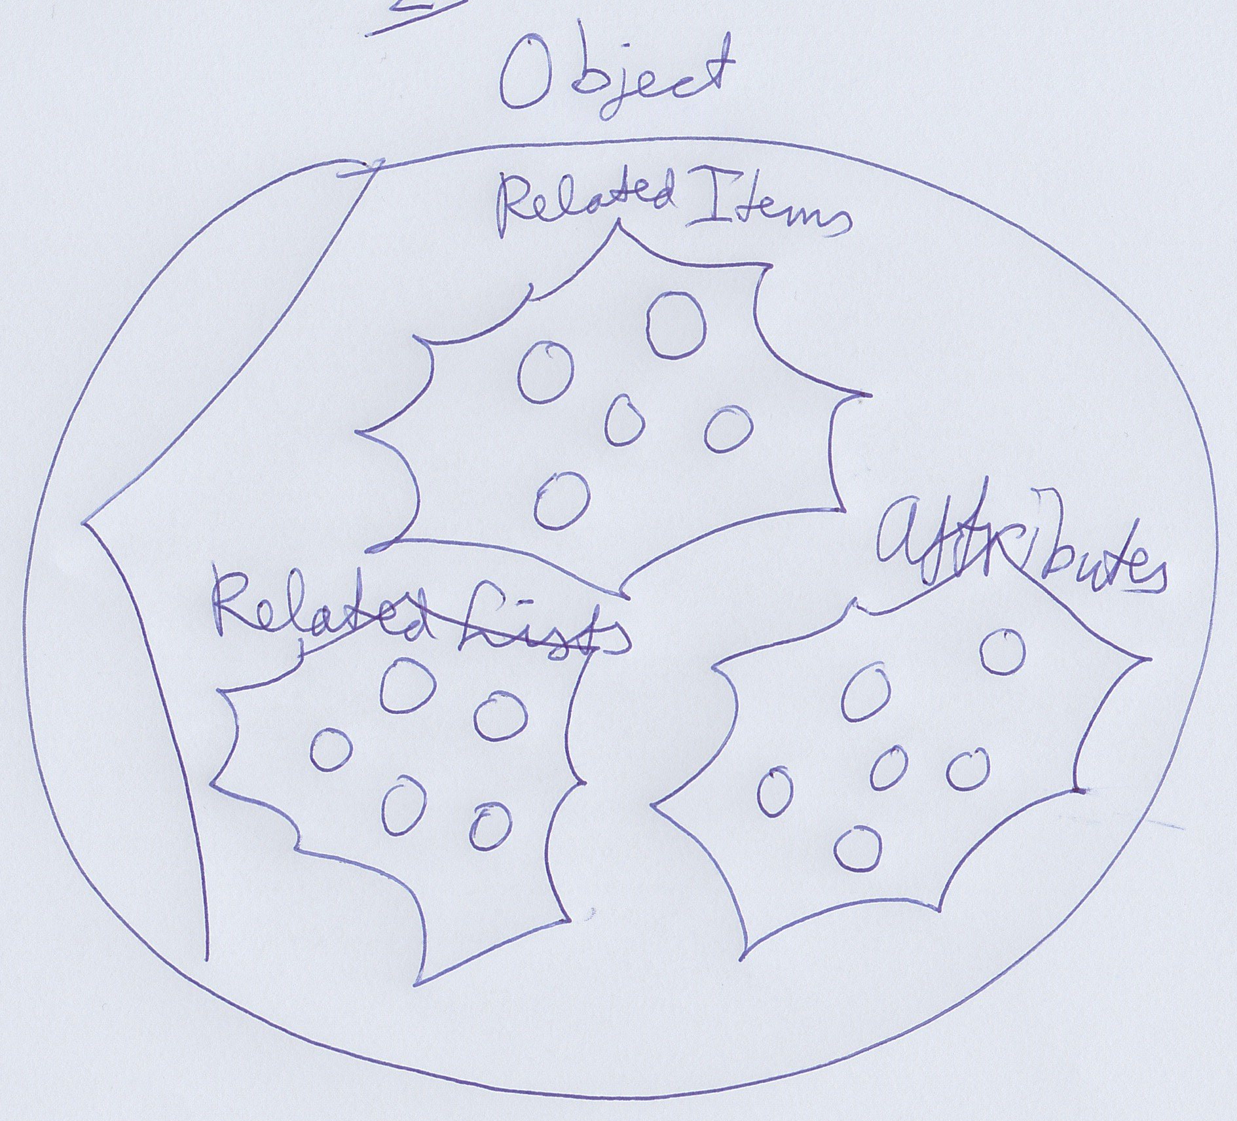

Here next to **Related Item**s, **Related Lists** there would be **Attributes**: basically the collection of simple loose values the object might hold.

It might go on. A **Commands** collection might be added for instance, to perhaps list sub-objects that are command symbols.

By now the suspicion might be, that it could be a quite arbitrary choice of collections.

An alternative could be that there is one collection of related objects, but separate enumerators to retrieve related lists, related items, attributes and commands separately.

This 'under the hood' data might be called reflective data by some. There are other systems, where you can take a class and retrieve separate lists of properties and methods for instance and the ability to read out the values or call the methods. That idea might be closely related to this one here. That way you might tap into data more generically based on characteristics, rather than pointing at specific objects.

#### Symbol

The term *symbol* mightbe used as a synonym for related item or for object. But there might be a subtle difference that a symbol might just be a shape displayed on screen. The same related item could be displayed on screen multiple times.

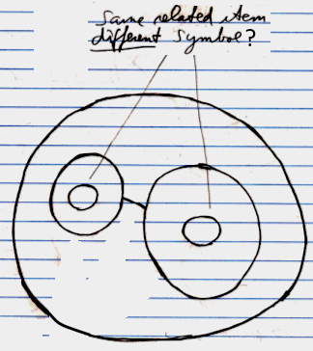

But the difference might be too subtle to talk about. A symbol might not be a system object, it might just a shape displayed on screen.

#### System Object

The terms above indicate different kinds of *system objects*, except for maybe the term *symbol*.

#### Summary

All the objects in this imaginary implementation of Circle might live as these system objects.

Here is a recap of terms introduced in this section:

**Object**

**Item**

**Reference**

**Related Object**

**Related Item**

**Related List**

**Related List Item**

**Related Items & Related Lists Collections**

**Reflective Data**

**Symbol**

**System Object**

### System Aspects

The behavior of objects, references and lists might be controlled by controlling their *aspects*. This section tries to list out various aspects of objects, references and lists. The pictures try to show a bit of each aspect’s diagram symbolization.

#### Object

The **Object** aspect may determine which object is pointed to.

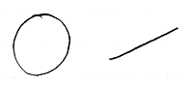

#### Class

The **Class** aspect might determine which other object would function as the prototype or class of another object. It can also bind a reference to a class.

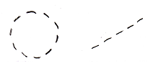

#### Interface

The **Interface** aspect might give control over how objects might look on the outside, while the insides of the objects may be different. The **Interface** aspect should be covered in the *Interfaces* chapter, and might not be mentioned any further in this chapter.

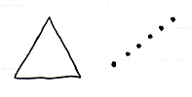

#### Value

The **Value** aspect might allow storing binary content and might allow yielding over values from one object to another.

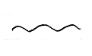

#### Execute

The **Execute** aspect might be about the ability to execute an object as a command.

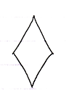

#### List

The **List** aspect may allow adding and removingitems from a list.

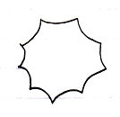

#### Name

The **Name** aspect may allow giving names to objects, lists and references.

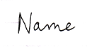

#### Existence

The **Existence** aspect might allow creating a new object. An object reference might also be annulled. Then it may point to nothing. Another option might be the ability to *check* whether an object reference "**Nothing**"or"**null**".

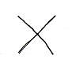

#### Data

With the data aspect the idea is to control reading or writing access. Instead of being able to access-control a single object, the **Data** aspect might control read-write access to all of the sub-objects as well.

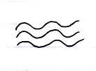

#### Clone

The proposed **Clone** aspect might be related to the **Value** aspect, but might also copy values of sub-objects.

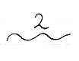

Its use might be that it may occur periodically that you might want to copy an object + its child values.

#### Summary

Here is an attempt to list the aspects again:

**Object**

**Class**

**Interface**

**Value**

**Execute**

**List**

**Name**

**Existence**

**Data**

**Clone**

### Object-Bound & Reference Bound Aspects

When using *system aspects*, there seems to be a subtle phenomenon that some aspects might to be bound to an *object*, while other aspects may be bound to a *reference*.

Object-bound aspects would be determined by an object. An object might also control its sub-objects’ reference-bound aspects. Therefore *reference-bound* aspects might also be called *sub-object-bound* aspects.

The following aspects may be object-bound:

**Value**

**Class**

**Execute**

**Clone**

**Data**

**List**

The following aspects might be reference-bound (or *sub-object-bound*):

**Object**

**Existence**

**Class**

**Name**

The **Class** aspect seems to be both object-bound as well as reference-bound. (The **Interface** aspect too, but that topic may be saved for later.)

The idea of object-bound aspects might help an object protect some of its characteristics and not be different depending on which object reference points to it.

An object seems to control its object-bound aspects as well as its sub-objects’ reference-bound aspects.

### System Commands & System Interfaces

#### System Interface Notation

Sometimes an object's normal members might be shown:

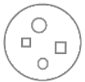

In this hypothetical Circle system, all objects are system objects under the hood. This might include normal objects, object references and lists. They might all be system objects deeper down. The members of a system object might be shown instead. This might be done by breaking open the inner workings of the object and show the *system interface*:

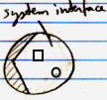

When the system interface is shown, normal members could be hidden, visible or maybe just part of them visible. The other way around, when normal members are shown, the system interface might be only part shown.

##### Example: System Interface of an Object

An **Object**'s normal members might look like this:

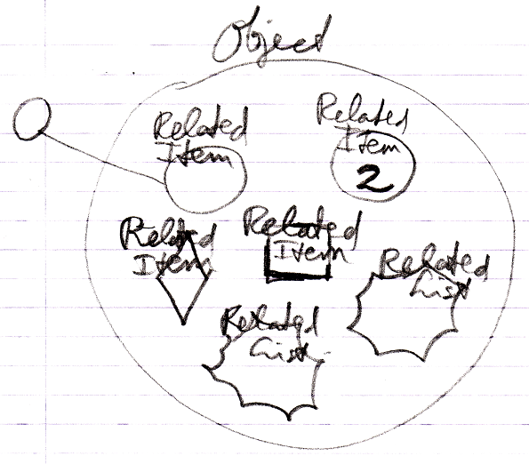

But when the **Object**'s system interface would be opened, then for instance the **Related Items** and **Related Lists** collections might be shown instead:

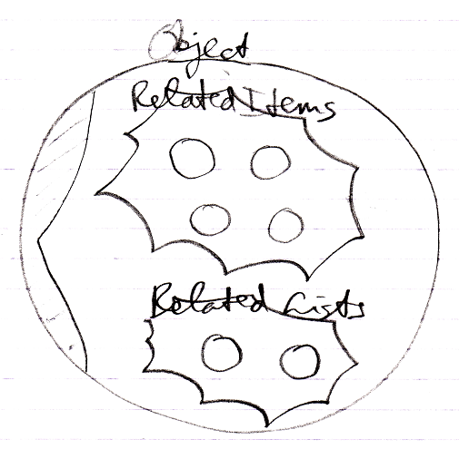

The **Related Items** and **Related Lists** mightbe displayed as circles here: regular objects, even when they are *commands* and even when they are *lists*. It might be an alternative to display the items with their original shape. More than one thing is possible. This new view with the system members, might be merely a representation of the way an **Object** could actually internally work.

##### System Commands

System *commands* could be the commands of system objects, through which the aspects of the objects may be controlled.

##### Aspects

Next to controlling *sub-objects*, the system interface might also control *aspects*, for instance, the **Value** aspect:

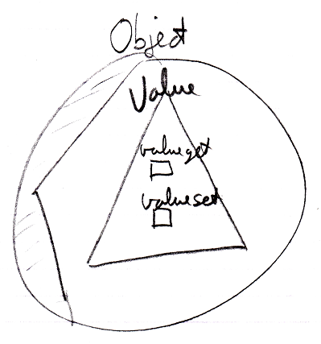

Several aspects could be given **Get** and **Set** commands. But each aspect might be controlled in a different way.

##### System Interface = Publics of System Objects

One idea that system interfaces may be based on, is that a system interface might be no more than public members of a system object. When this description here about system interfaces would be incomplete, what might be missing may be derived from the idea, that the system interface may simply show public members of a system object. Another idea derived from that could be that the *private* workings of system objects might not be shown in the system interface. But these may be mere guidelines to have something to hold on to.

##### Origin of the System Interface Notation

The notation of the *system interface* may be derived from the *interface* notation. When an object would have several interfaces, each interface might be shown as a triangle inside the object:

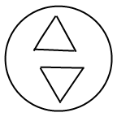

But showing the system interface would be like showing the interior ‘of the symbol itself’. Therefore, the triangle of the system interface might be creatively stuck to the border of the symbol:



That way the interface might look more part of the object itself, rather than being a sub-object.

To make more room inside the system interface the following, exaggerated notation would be proposed:



It also kind of looks as if the shell of the symbol is broken open is showing its inner workings. Like having opened up the system and we might see its internal wiring. It might be like seeing the setup of the symbol machine.

#### System Interface for the Class Aspect

The **Class** aspect might have a bit more to to say about it than other aspects.

##### Class may be both Object-Bound and Reference-Bound

The **Class** aspect might apply to both objects and references, but differently. In the example system here, an object would have a certain class, which would be fixed upon creation of the object and throughout its lifetime. A reference also could have a class, aiming to indicate which class of object might be assigned to the reference. In this example, the class of an *object* might never change. The class of a reference might be changed, but only when it would be compatible with the object assigned to it. When the reference would be **Nothing** or **null**, any class might be assigned to the reference.

**Object-Bound Class** and **Reference-Bound Class** could point to the same class. The **Reference-Bound Class** could also be a base class of the **Object-Bound Class** or an interface of it.

##### The Object-Bound Class Aspect in the System Interface

The **Class** aspect has *several* system commands, but only *two* of them apply to **Objects**. The other ones apply to references. The **Class** aspect of an **Object** is controlled through the following commands:

**Use As Class**

**Object-Bound Class Get**

**Use As Class** might belike **Object Get**, but then for using that object as the class of another object. This may be the most common usage of the class aspect. The separate system command **Use As Class**, might also be used at one point to separately access control whether an object might be used as a class or not.

The command **Object-Bound Class Get** may return the class object associated with an object. That command might not be used as commonly.

The commands are placed inside a triangle, that wraps together the members of the **Class** aspect:

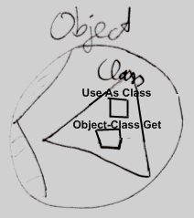

##### The Reference-Bound Class Aspect in the System Interface

The **Class** aspect has *five* system commands, but only *three* of them apply to **Related Items**:

**Class Set**

**Reference-Class Get**

The **Class Set** command might be executed on an object reference. The reference might then only point to objects of that class. In our hypothetical system here **Class Set** mightapply only to references and possibly not to objects, because the class of an object might only be set upon creation.

The command **Reference-Bound Class Get** may return the class object associated with an object. That command might not be used as commonly.

The commands are placed inside a triangle, that wraps together the members of the **Class** aspect:

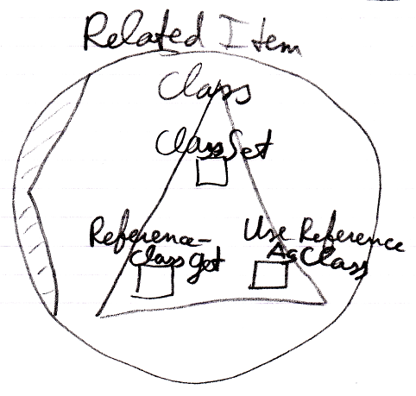

< Erase "Use Reference As Class"? >

##### System Commands for the Class Aspect

This leaves us with the following commands:

**Use As Class**

**Class Set**

**Reference-Bound Class Get**

**Object-Bound Class Get**

#### System Interface of an Object

The main thing you see when showing the system interface of an **Object** is the **Related Items & Related Lists** collections.



But apart from sub-objects, an object has the following aspects:

**Value**

**Class**

**Execute**

**Clone**

**Data**

They are controlled through system commands. Those commands will also be visible inside the system interface.

##### The Value Aspect in the System Interface

The **Value** aspect is controlled through two system commands:

**Value Get**

**Value Set**

**Value Get** gets the value of an object.

**Value Set** sets the value of an object.

The **Value** aspect is represented by a triangle, that wraps together the members to control the **Value** aspect:



##### The Execute Aspect in the System Interface

The **Execute** aspect only applies to executable objects, also called commands. The **Execute** aspect is controlled through one system command:

**Execute**

You can access control being able to execute a command. Some commands are never meant to be executed, because they are a definition.

The command is placed inside a triangle, that wraps together the members of the **Execute** aspect:

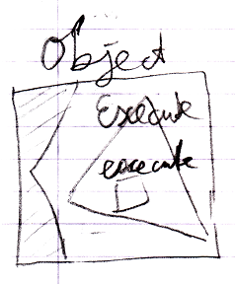

##### The Clone Aspect in the System Interface

The **Clone** aspect is controlled through two system commands:

**Clone Get**

**Clone Set**

The **Clone** aspect is related to the **Value** aspect, but will also copy the sub-objects’ values.

**Clone Get** copies the object and sub-objects. **Clone Set** assigns the cloned values to another object. This can also be a new object.

Both commands have a parameter, that defines the cloning depth: the depth at which to clone sub-objects. When the cloning depth is **2**, then this is also expressed as:

**Clone (2) Get**

**Clone (2) Set**

The commands are placed inside a triangle, that wraps together the members of the **Clone** aspect:

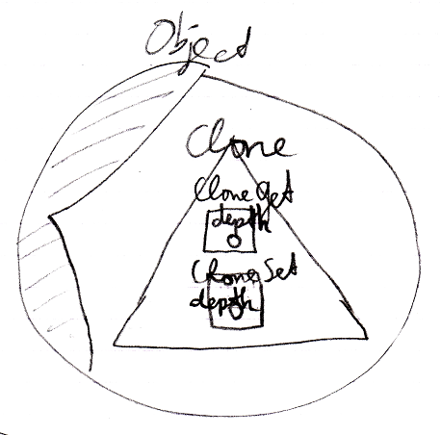

##### The Data Aspect in the System Interface

The **Data** aspect is controlled through two system commands:

**Data Get**

**Data Set**

The **Data Get** and **Data Set** command can not be called; they can only be access-controlled to control read-write access to the object and all the contents of the object: any sub-object or deeper object.

The **Data Get** command abstractly represents any *read*, in other words: any possible **Get** call to any sub-object. The **Data Set** command abstractly represents any *write* to any sub-object.

The commands are placed inside a triangle, that wraps together the members of the **Data** aspect:

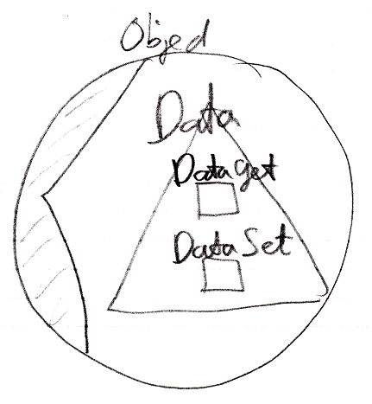

##### The Full System Interface for Object

The full system interface of an **Object** looks like this:

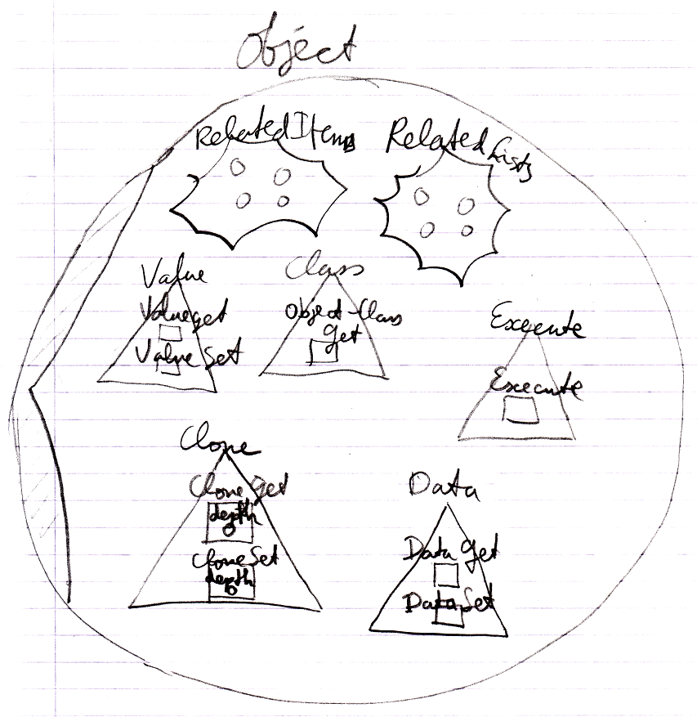

#### System Interface of a Related Item

When you open up the system interface for a **Related Item**, you get to see the system commands that apply to **Related Items**. Aspects, that apply to a **Related Item** are:

**Object**

**Existence**

**Class**

**Name**

##### The Object Aspect in the System Interface

The **Object** aspect of a **Related Item** is controlled through several system commands:

**Object Get**

**Object Set**

**Object Get** retrieves the targeted object of a reference.

**Object Set** changes an object reference target.

The commands are placed inside a triangle, that wraps together the members of the **Object** aspect:

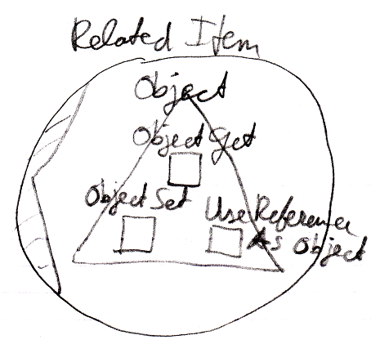

< Erase "Use Reference As Object"? >

##### The Existence Aspect in the System Interface

The **Existence** aspect is controlled through the following system commands and an attribute:

**New**

**Annul**

**Is Something**

The **New** command has an optional **Class** argument, with which you can indicate the class to create a new **Object** from.

There is also the system attribute **Is Something** which returns **True** or **False**, also represented by the terms **Something** or **Nothing**.

The members are placed inside a triangle, that wraps together the members of the **Existence** aspect:

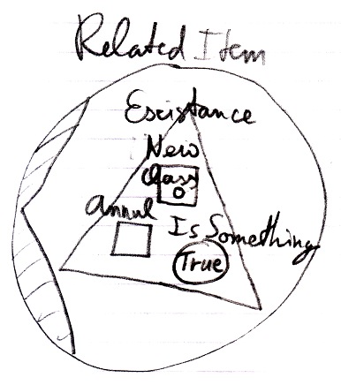

##### The Name Aspect in the System Interface

The **Name** aspect is controlled through two system commands:

**Name Get**

**Name Set**

**Name Get** gets the name of an object, reference or list.

**Name Set** sets the name of an object, reference or list.

The commands are placed inside a triangle, that wraps together the members of the **Name** aspect:

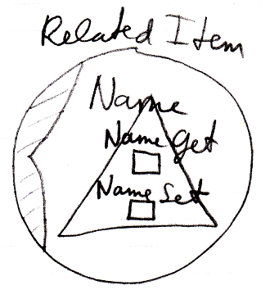

##### The Full System Interface for Related Item

The full system interface of a **Related Item** looks like this:

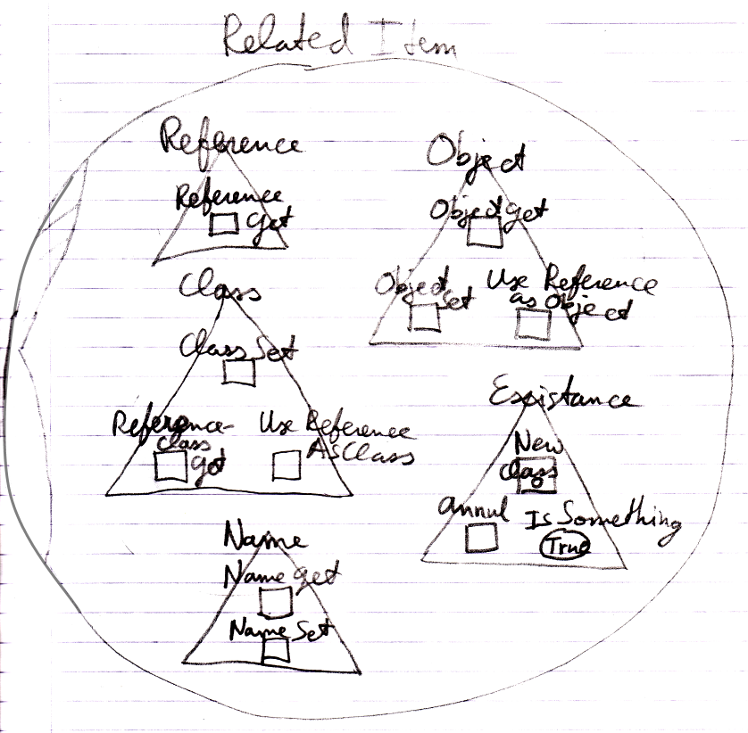

< Erase "Reference", "Use Reference As Object" and "Use Reference As Class"? >

#### System Interface of a Related List

When you open up the system interface for a **Related List**, you get to see the system commands that apply to **Related Lists**. Only the **List** aspect applies to **Related Lists**. The system interface of a **Related List** will show the **Add** command. The **Add** command has an optional **Item** argument, to add an existing item to the list.

So the system interface of a **Related List** looks like this:

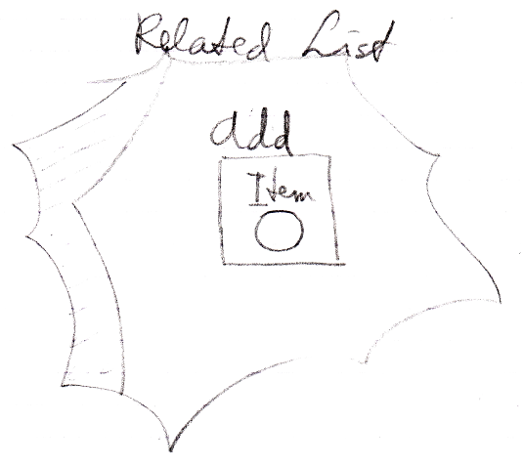

But more members may be introduced later. Specifically you probably would want to centrally control the **Class** aspect of all the items in the list.

The **List** aspect is controlled through the following system commands:

**Add**

**Remove**

The **Add** command is part of a **List** object. The **Add** command adds an item to the list. This may be an existing item, passed through the optional argument **Item**. You can also create a new item for it, possibly of a new class, using the **New** command, which is part of the **Existence** aspect.

The **Remove** command is part of a **Related List Item**. It removes that item from the list.

#### System Interface of a Related List Item

When you open up the system interface for a **Related List Item**, you get to see the system commands that apply to **Related List Items**. Aspects, that apply to a **Related List Item** are:

**Object**

**Existence**

**Class**

**List**

Those are the same as a **Related Item**, minus the **Name** aspect, plus the **List** aspect.

Only the **List** aspect for the **Related List Item** is explained here. The other aspects were already worked out in the section *System Interface for Related Item*.

##### Related List Item’s List Aspect in the System Interface

The **List** aspect of the **Related List Item** is represented by:

**Remove**

The command, which removes the item from the list

**List**

A reference to the **List** that the **Related Item** is part of.

The members are placed inside an interface, that wraps together the members of the **List** aspect:

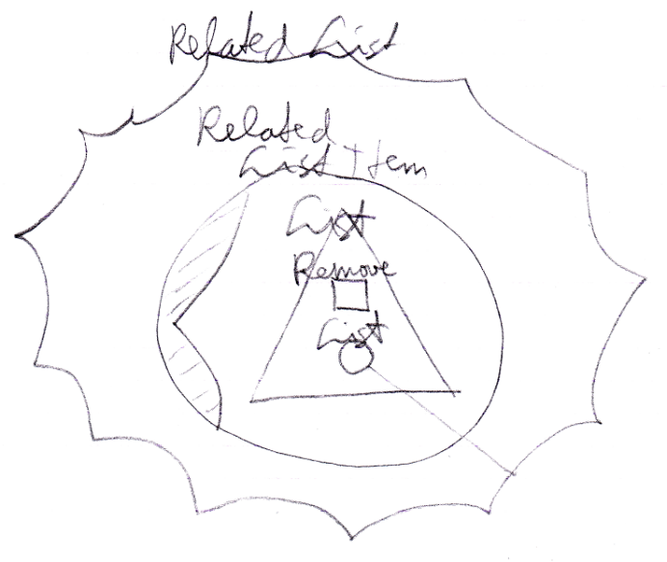

##### The Full System Interface for Related Item

A **Related List Item** is almost the same as a **Related Item**, so the full system interface of a **Related List Item** also shows all the other aspects:

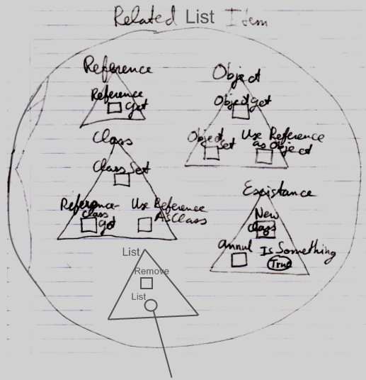

< Erase "Reference", "Use Reference as Object" and "Use Reference as Class"?>

### Design Choices

#### Use-Command Gets Another Aspect

The **Use As Class** command is part of the **Class** aspect but **Gets** the **Object** aspect.

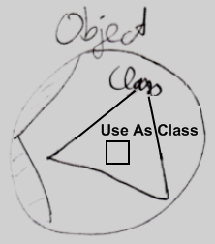

A **Use** command **Gets** a different aspect than what it applies to. The **Use Reference As Object** command is part of the **Object** aspect but **Gets** the **Reference** aspect. The **Use Reference As Class** command is part of the **Class** aspect, but **Gets** the **Reference** aspect. < Is it an idea to reword this to something about the **Use As Class** command instead? >

How a **Use** command delegates to a **Get** command of the other aspect is not visible in the system interface, because that is private implementation. You only get to see the public members of the system objects, not their implementation.

#### Aspect-In-A-Triangle

An aspect is represented by a triangle containing system commands:



It was a design choice to have system commands placed inside a triangle, that represents the aspect, because it does not always look best to explicitly qualify each **Class** command with "**Class .**" So you can directly call the **Use As Class** command and not use something like:

**Class . Use As Class**

**Class . Use Object As**

**Object . Use As Class**

That last one *looks* fine, but places a class-related action inside the **Object** aspect, which you do not want, because you want to keep all commands that apply to the **Class** aspect together under the **Class** aspect.

All-in-all: this is a design choice.

#### System Interfaces of Objects and References

There are system commands that apply to **Objects** and system commands that apply to **References**, but when you show the system interface of a symbol, which do you show? The system interface of the **Object** or the system interface of the **Reference**?

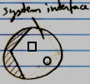

The solution for this problem is that you always deal with *references* to objects, never with the object directly, so when you open up the system interface of a symbol, the system interface of the **Reference** is shown. However, inside of it you will find the referenced **Object**, showing its system interface.

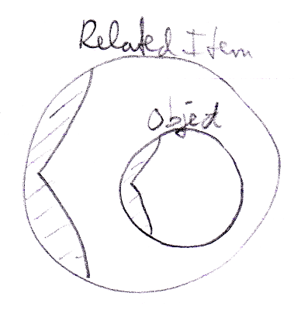

#### Preliminariness of the System Interface Notation

The basics of the system interface notation are not preliminary. But the system interface shows the exact public members of the code base objects. If the code base were to be programmed differently, the system interface members will also look different. Design choices were made in this documentation, which influenced the notation of the system interface members. Perhaps when implementing the code base in the future, different design choices are made and that will change the way the system interfaces look.